**Practical 14** Prepare a use case diagram and sequence diagram for a computer email system

**Use case diagram**

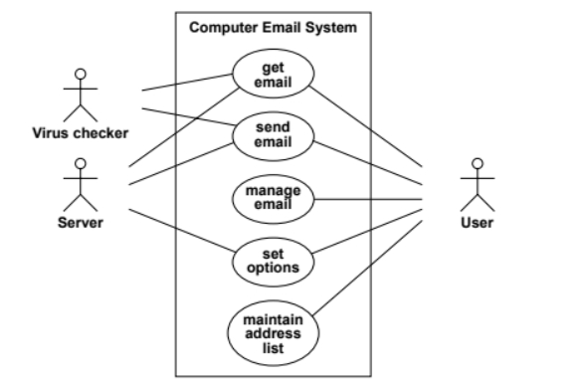

**Sequence Diagram**

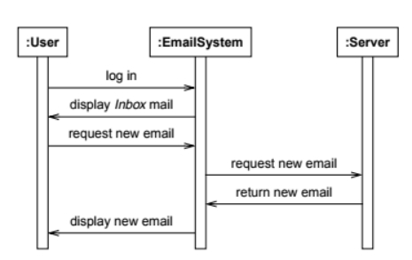

**Sequence diagram for Sending Mail**

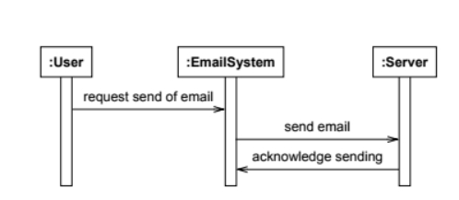

**Sequence diagram for Setting Option**

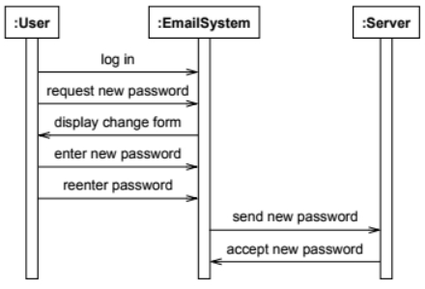

**Sequence diagram for Managing Mail**

